Evaluator: Pontus Svensson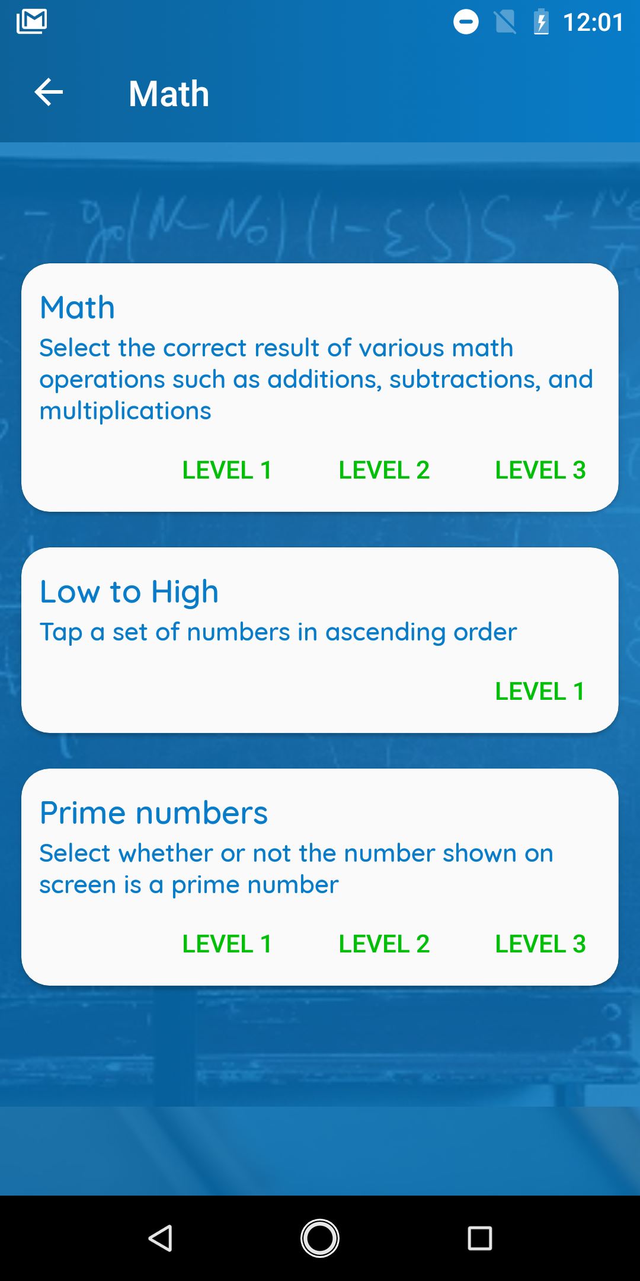

Reviewer: Leonardo Iwaya

DATE: 25/03/2024

Task: Play a game in the math section.

1. The screenshot displayed to the right reveals that the text and clickable buttons/texts appear relatively small, which could pose readability and usability challenges, particularly for older adults. This observation potentially violates the first heuristic, **"visibility of system status"**, which suggests that interfaces should prioritize ease of comprehension by minimizing unnecessary distractions. Considering the space available in the window, increasing the font size would likely address this issue. Additionally, it's worth noting that the buttons for Level 1, Level 2, and Level 3 are not obviously clickable. They could be enhanced to resemble buttons more closely.

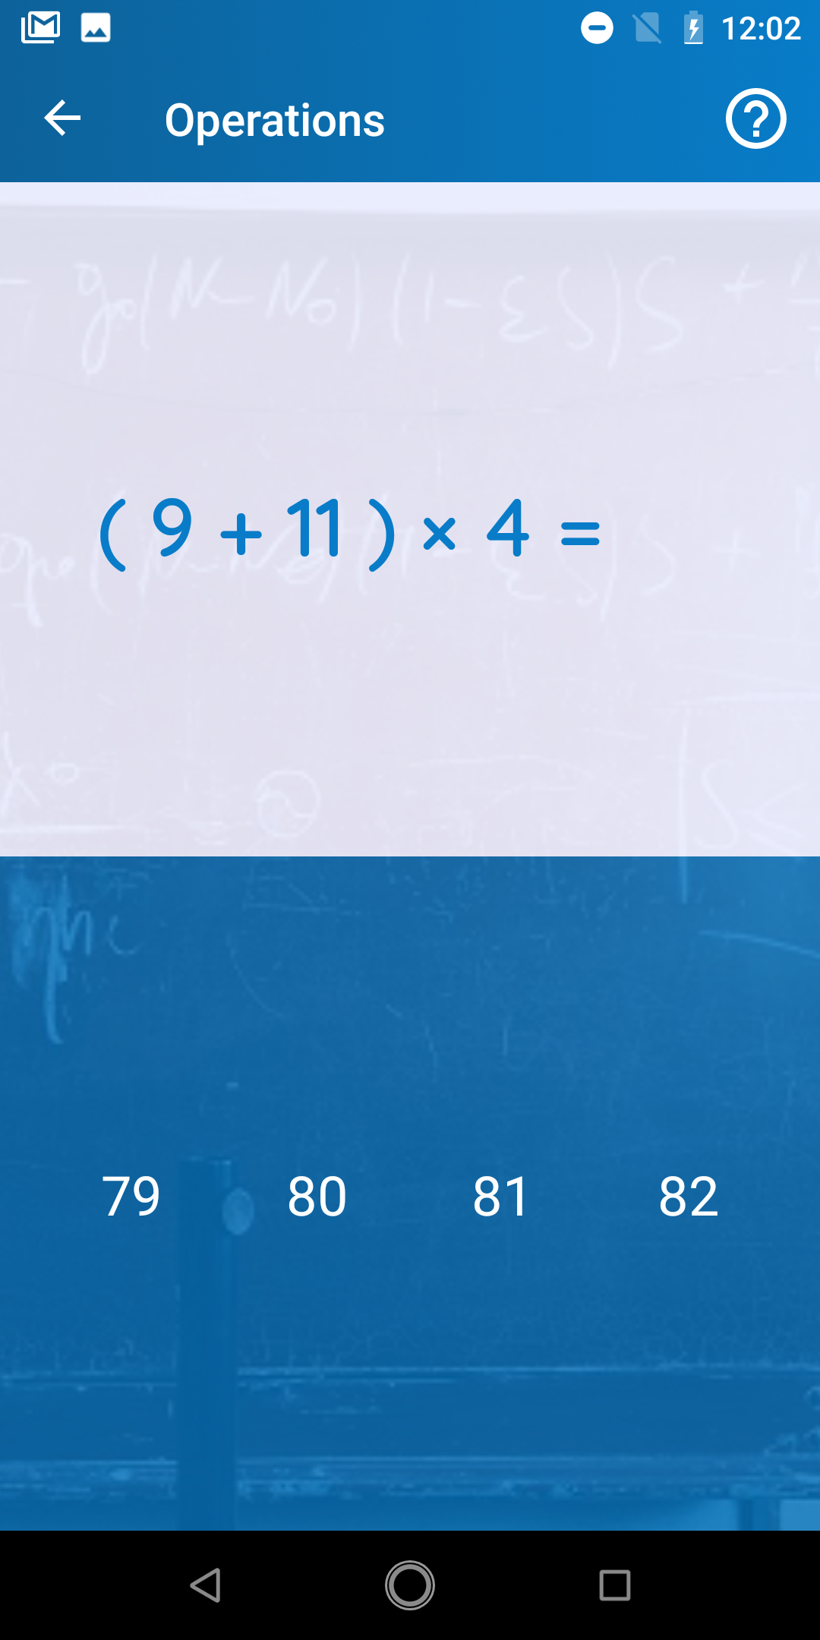

2. In the screenshot on the right, the user is asked to calculate the correct answer to an equation. However, if the user selects a number that does not match the correct answer, no feedback is provided—no message indicating an incorrect selection or any other indication. This lack of feedback violates the ninth heuristic, **"recognize, diagnose and recover from erros”**, which emphasizes the importance of using traditional error messages which are easily understandable by the user.

TASK: Watch a video in the “video” section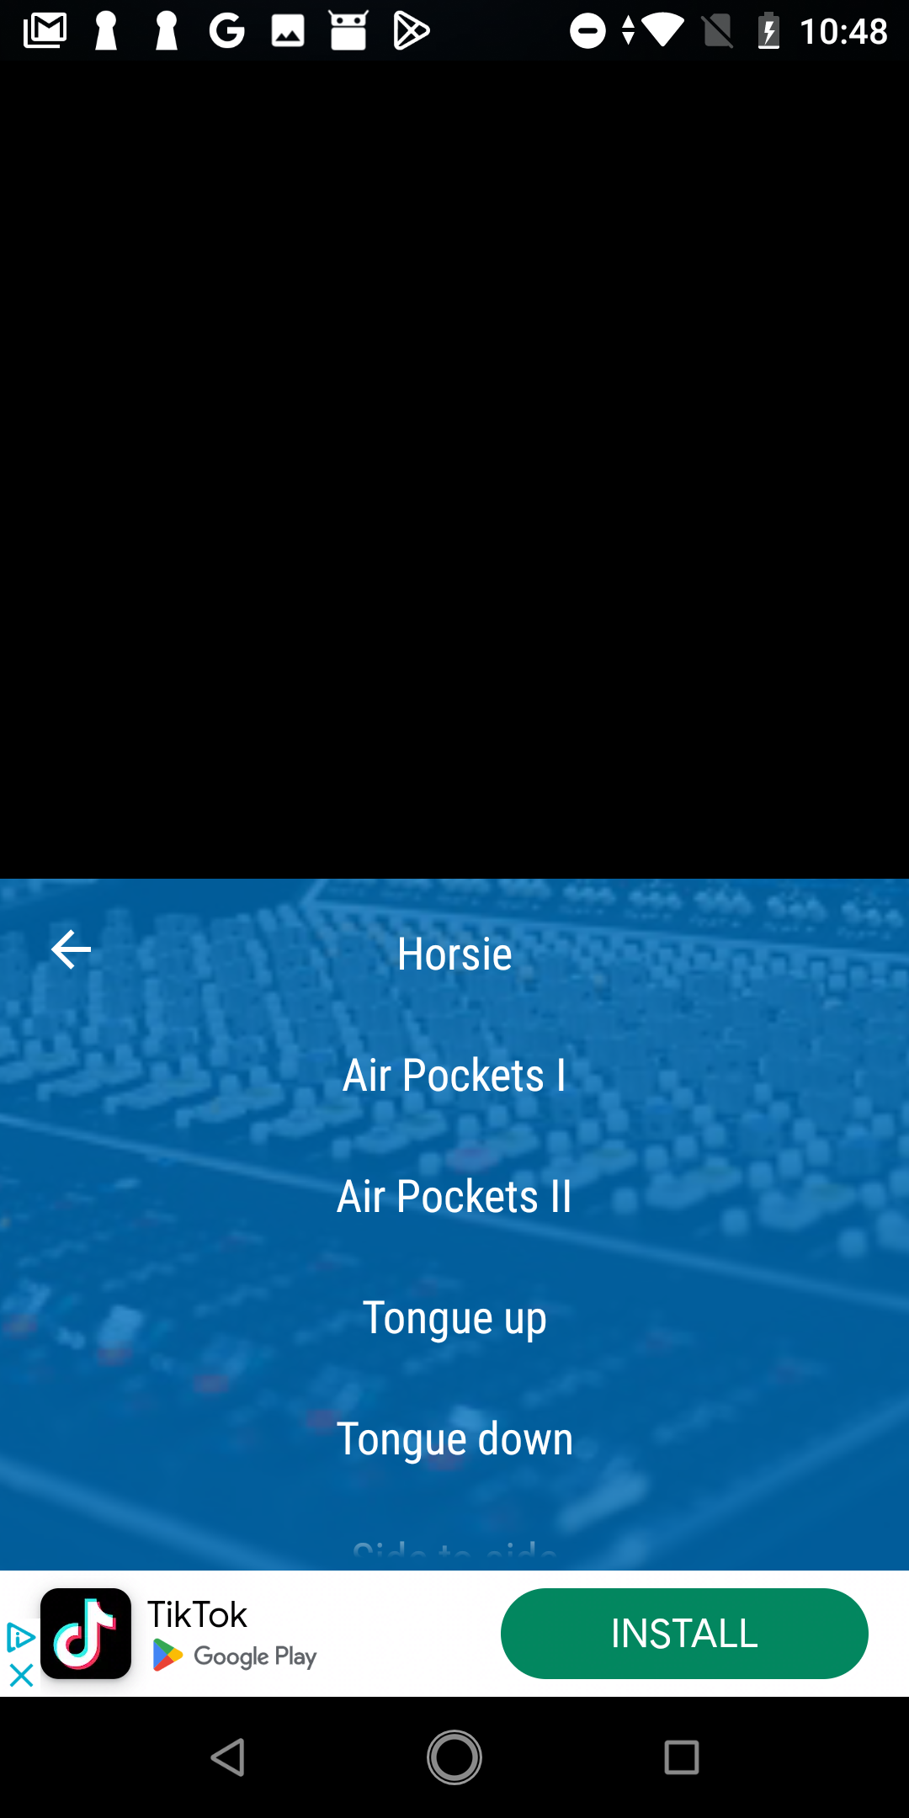

3. The video section does not work in the application, as when you try to watch a video, it never loads, and all that is shown is a black screen; nothing happens when you try to run any of the videos.

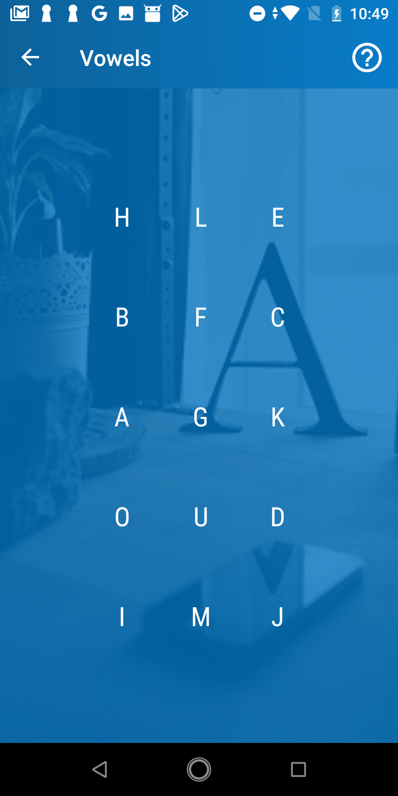

TASK: Play a game in the language section

In the screenshot to the right, we can see the game “Vowels”. The point of the game is to press all vowels, that is: A, O, U, E, I. Some individuals might have forgotten what a vowel is and which letters these are; this is not explained in the application; they only need to find every vowel. You could say that this either violates heuristic six or/and ten, **“recognition rather than recall”** says that information should be kept visible so users do not have to remember it and **“help and documentation”** says that help should be provided in the context right at the moment when the user needs it.